

SPEAKER’S CORNER
Organised by the Members Advisory Committee

Wednesday 22nd April 2026
Leasingham Village Hall, NG34 8GQ
7.30pm to 9.30pm
An informal evening with a chance for members to meet and listen to prospective new WI speakers as they give a brief presentation about themselves and their talk/s.
Tickets - £7.50 (Tea/Coffee and Biscuits included)
(Treasurer can pay from WI funds for Programme Secretary to attend)

CLOSING DATE FOR APPLICATION IS – SUNDAY 5th APRIL



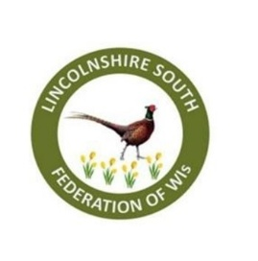
APPLICATION FORM – SPEAKERS CORNER
Wednesday 22nd April 2026
Closing date: Sunday 8th April 2026
Name of WI ………………………………………………………………………
Contact Email ……………………………………………………………………
 | Name of Attendee | Phone Number
1
2

3

4

5

6

7

8

Application forms should be returned either by post to WI Office, Pattinson House, Oak Park, East Road, Sleaford NG347EQ or by email to events@lsfwi.org.uk with MACSC as the subject plus the name of the WI as the reference to arrive no later than Sunday 8th April
BACS is the preferred payment method but DO NOT make a payment until the application has been confirmed.
Cheque payments to be made payable to: LSFWI and posted to the office to arrive no later than 8th April.
Please note – cancellations made by applicants before the closing date given will not be charged, however cancellations made after the closing date must be paid for. If an event it oversubscribed a ballot for places will take place – with members taking priority. Thank you

