Behind the Scenes at Stamford Shakespeare Company
Organised by the Activities Committee

Tolethorpe Hall, Little Casterton, Stamford PE9 4BH
Wednesday 14th September at 2pm
Members £10.00 Non Members £11.00
To include: Site tour with Q&A plus refreshments.
NB. Travel is not provided, please make your own way there.
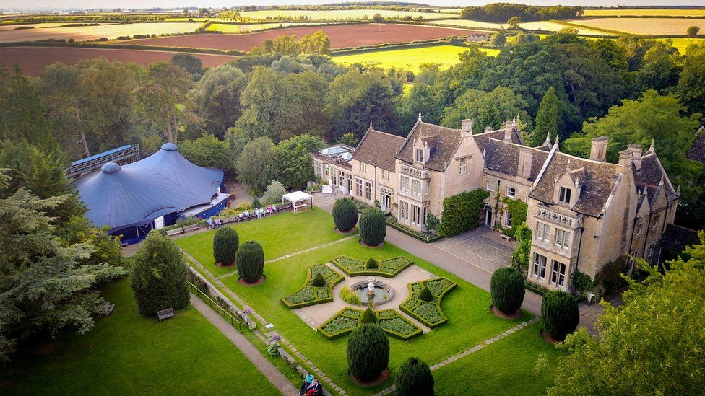

When the season finishes at the end of August, SSC team are running Behind the Scenes tours from September which takes groups behind and under the stage, through all the various rooms housing the incredible range of costumes, sewing rooms etc. At the end of the tour, refreshments are served in the conservatory.
- Please be aware that there are several stairs in the Hall as the Costumes are housed in the top floor rooms.
- Tours will be split into small groups so that everyone gets a better experience.
Closing date for ticket applications August 18th
Application Forms will be with your WI’s Secretary
If this event is oversubscribed, we will attempt to book a second date.

www.stamfordshakespeare.co.uk

