An afternoon of music & comedy to chase away our blues!
HMS Pinafore
Wednesday 4th August 2021 at 2.30 pm.
£40 for members, £42.00 for non-members.
Closing date 30 June 2021
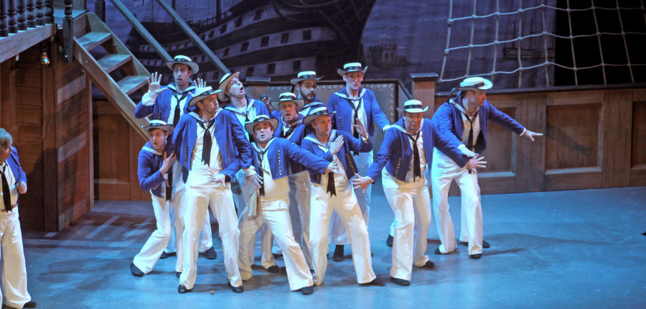
Maximum numbers 15

The Pinafore, a "saucy" beauty of a ship in Her Majesty's navy is anchored in the harbour at Portsmouth. Its proud sailors are busy scrubbing the decks ……………………………………………
Come with us to Buxton Opera House as the National Gilbert & Sullivan Opera Company set sail on HMS Pinafore in a hilarious, brand-new production of this all-time favourite. Gilbert & Sullivan productions are light-hearted timeless classics that poke fun at everything and anything. With its iconic songs “To be an Englishman” and “Poor Little Buttercup” this should be a great afternoon!
Please note:
- This is a ‘make your own way’ event in view of travel and contact restrictions which are likely to remain in force for some time yet.
- Refunds will only be given if the performance is cancelled by the Buxton Opera House.
- Buxton Opera House, Water Street, Buxton, SK17 6XN

To apply for a place, send an e-mail with ‘HMS Pinafore’ as the subject to events@lsfwi.org.uk by 30th June 2021 ensuring that you include your name, WI, contact e-mail, and phone number.
BACS is the preferred payment method but DO NOT make a BACS payment until your place is confirmed when you will be sent the bank details and asked to pay by 10th July 2021 to secure your place.
If you need to pay by cheque, send your cheque payable to LSFWI to LSFWI, Suites 9&10, Pattinson House, East Road Trading Estate, SLEAFORD NG34 7EQ to arrive by 30th June 2021.
To minimise costs, any WI able to consolidate applications into one cheque should do so. Any cheques received where a place is not allocated will be destroyed.

