RUTLAND WATER WALK

Wednesday 7th September 2022
Starting at 10:30am from The Finch’s Arms Oakham Road, Hambleton, Rutland, LE15 8TL
Members £3 Non-Members £5
Lunch afterwards at The Finch’s Arms is not included in the price
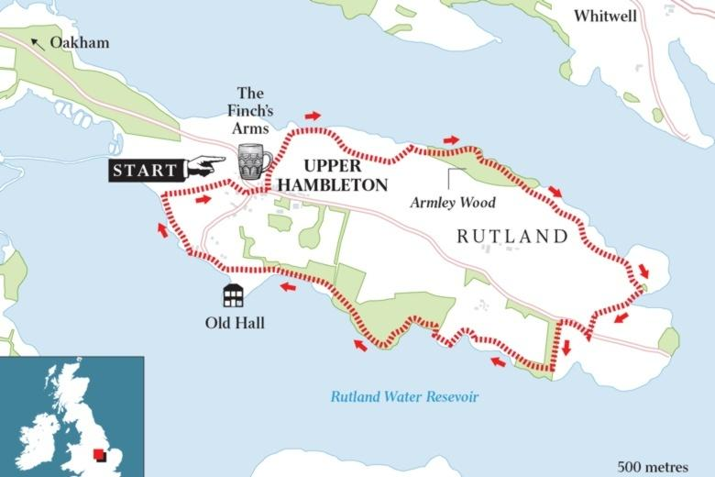

Why not take a drive down to Rutland Water and join us on this beautiful 5 mile walk around the Hambleton Peninsula with its stunning views across the water to Normanton Church. The walk is mostly on hardstanding but with some areas less good underfoot and some steeper sections but is, overall a fairly easy walk.
Anyone lunching at The Finch’s Arms will be asked to make their lunch choice prior to departure on the walk.
To apply by e-mail/BACS (preferred application method). Send an e-mail to events@lsfwi.org.uk using SEP22WALK as the subject. Ensure that you include the 8 pieces of information requested overleaf. DO NOT make a BACS payment until your place is confirmed when you will be sent the bank details and asked to make payment to secure your place.
To apply by Cheque/letter. If you need to pay by cheque, send your cheque payable to LSFWI with the 8 pieces of information requested overleaf to LSFWI, Suite 10, Pattinson House, East Road Trading Estate, SLEAFORD NG34 7EQ to arrive by 15 August 2022. Any cheques received where a place is not allocated will be destroyed.

Refunds will only be made if the event is cancelled by the Federation.

Closing date for entries: Monday 15th August 2022
READ PRIOR TO APPLYING FOR A PLACE
All participants must be aware they walk at their own risk and they are responsible for their own safety and happiness on the walk. The walk leader will lead the walk and will carry a small first aid kit but will not have specific medical training. The walk leaders will show their group the way on the walk but it is up to the individual to be careful in following them and to know their own capabilities and limitations.
You must provide an Emergency Contact Name and number they can be contacted on for the duration of the walk. You will be given the walk leader’s mobile number prior to the event.
Should any walker have underlying health problems, such as diabetes or asthma, that may affect them during the walk they must ensure that this is included in their application. Similarly if a known condition requires medication that may be needed on the day it must be brought even if it is only required for emergencies, and the walker must explain to either the walk leader or a trusted companion what to do should an emergency arise.
All participants must arrive with:
Suitable footwear i.e. trainers or walking shoes/boots
(Unless the route recce in the days prior to the event shows otherwise, trainers are sufficient for this walk)
Water/fluid
Any medication that might be needed
Mobile phone that is switched on throughout the walk
Suitable clothing for the day (e.g. a waterproof if wet, a sun/rain hat, )
Suntan lotion applied if hot

Anyone arriving in unsuitable clothing, unsuitable footwear (such as loafers or flip flops), or having failed to provide emergency contact details will not be allowed to join the walk. Refunds will not be made in this instance.

Application form/Information that MUST be included in your e-mail
- Name
- WI
- Mobile Number
- Contact Telephone Number if different from mobile
- Emergency Contact Name
- Emergency Contact Telephone
- Medical conditions - Give details
- Lunch required at The Finch’s Arms? | Yes/No

