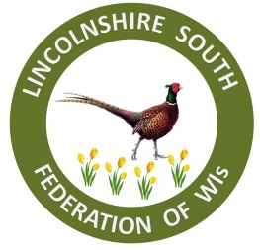
FEDERATION DAY
SLEAFORD
RUGBY CLUB
David Williams Pavilion, East Road,
Sleaford NG34 8SP
SATURDAY 16 JULY 2022
11am – 3.30pm

TICKETS: £12.50
TO INCLUDE:
LUNCH
Of lasagne, salad and bread followed by choice of cake
(gluten free available – please advise any other dietary requirements)
MORNING SPEAKERS
AFTERNOON ENTERTAINMENT
RAFFLE
Tea and coffee available on arrival.
Come along and meet your WI friends
Ample free parking. Wheelchair access
Closing date for entries: Wednesday 29 June 2022
Please complete the attached application form
A ballot will take place if this event is over subscribed

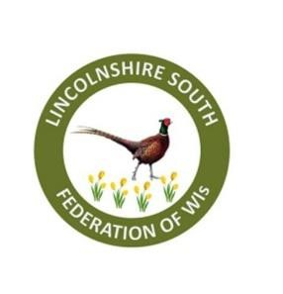
APPLICATION FORM – Federation Day 16 July 2022
WI………………………………………………………….
Contact …………………………………………..Email: ……………………………………………
Tel: ..........................................................
 | Name of Attendee(s)  BLOCK CAPITALS PLEASE | Contact Phone No:  Home/Mobile | Food Allergies
1
2

3

4

5

6

7

= | Tickets required: Members |  | Total £
To apply please send the application form either by post to WI Office, Pattinson House, Oak Park, East Road, Sleaford NG34 7EQ or by email to fedoffice@lsfwi.org.uk using FEDJUL as the subject.
To arrive no later than 29 June 2022
Payment by BACS or cheque (delete which one is not applicable)
BACS to Lloyds Bank, Sort Code: 30 90 89 Account: 43337760. Name of Account: LSFWI.
When paying by BACS please use ref: FEDDAYJUL and your WI eg FEDJUL/NAVENBY
PLEASE DO NOT MAKE A BACS PAYMENT UNTIL YOUR PLACES ARE CONFIRMED.
Cheques made payable to LSFWI and posted to office address:
WI Office, Pattinson House, Oak Park, East Road, Sleaford NG34 7EQ. 01529 302398
Or by BACS to Lloyds Bank, Sort Code: 30 90 89 Account: 43337760. Name of Account: LSFWI. When paying by BACS please use ref: FEDDAYJUL and your WI eg
Refunds will only be given if the event is cancelled by the Federation, your application is late, or you were unsuccessful if a ballot took place.

